***Bash Scripting.***

1. **Basic scripting Hello world:**

* Create a directory with name “Scripting” to store all the scripting files at a single location, for easy to access and avalibility.

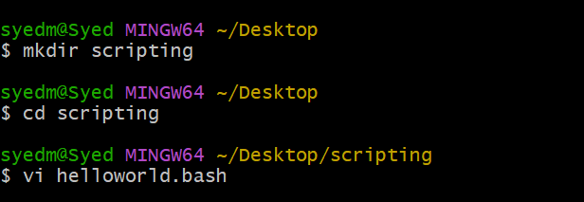

* Create a scripting file with the extension.bash
* Create a basic welcome script.

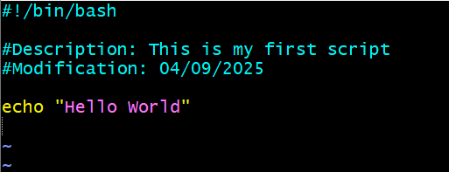

* Change the file permission for execution, change the permission to 755

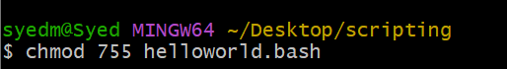

* Execute the file by keyword = ./

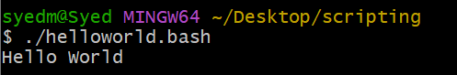

1. **Scripting of small tasks:**

* Create a scripting file under Directory scripting with the extension.bash
* Create a script for defining small task

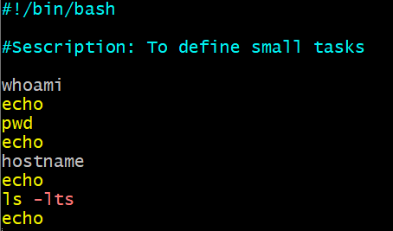

* Change the file permission for execution, change the permission to 755



* Execute the file by keyword = ./

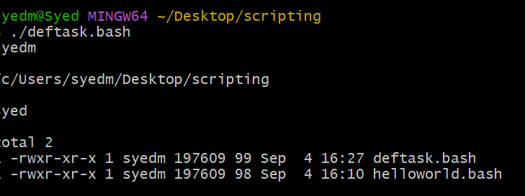

1. **Defining Variabales:**

* Create a scripting file under Directory scripting with the extension.bash
* Create a script for defining variables.

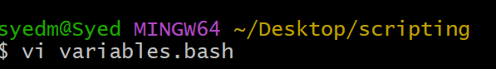

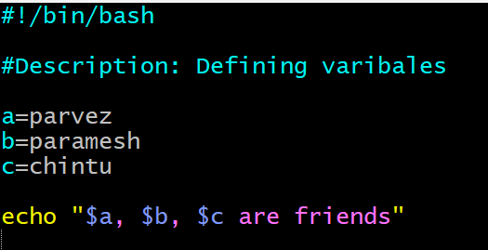

* Change the file permission for execution, change the permission to 755

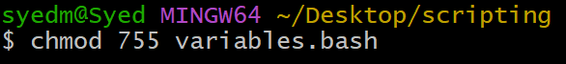

* Execute the file by keyword = ./

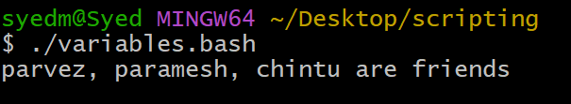

1. **Read input:**

* Create a scripting file under Directory scripting with the extension.bash
* Create a script for Reading inputs.

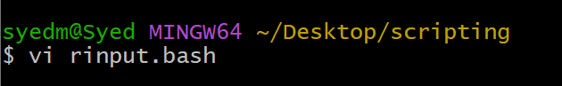

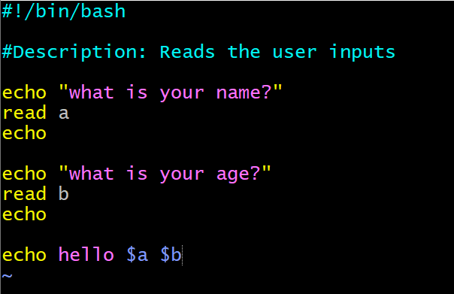

* Change the file permission for execution, change the permission to 755

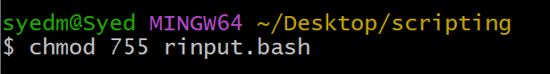

* Execute the file by keyword = ./

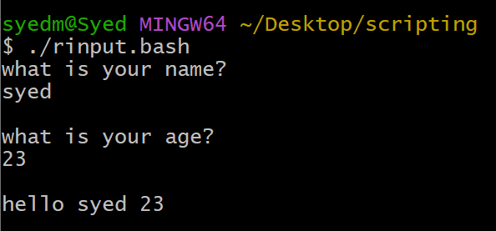

1. **Scripts to run commands within :**

* Create a scripting file under Directory scripting with the extension.bash
* Create a script to run commands wihtin.



* Change the file permission for execution, change the permission to 755

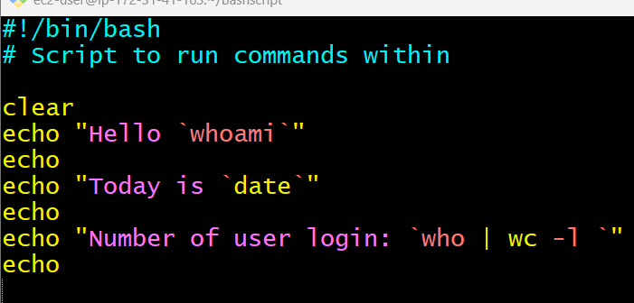

* Execute the file by keyword = ./

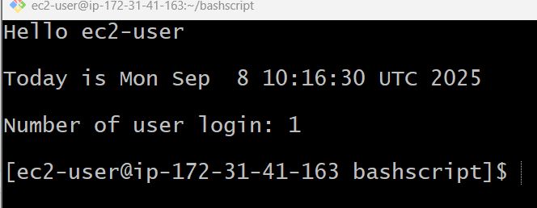

1. **Read input and perform task:**

* Create a scripting file under Directory scripting with the extension.bash
* Create a script to run commands wihtin.

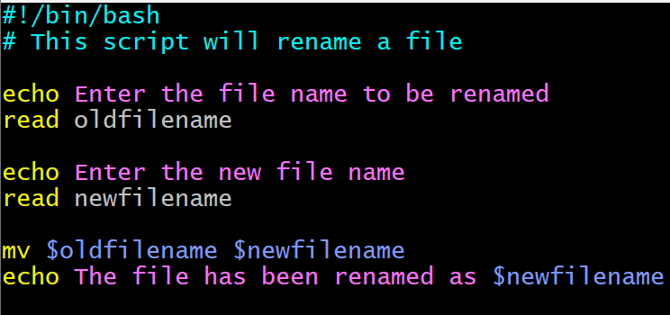

* Change the file permission for execution, change the permission to 755

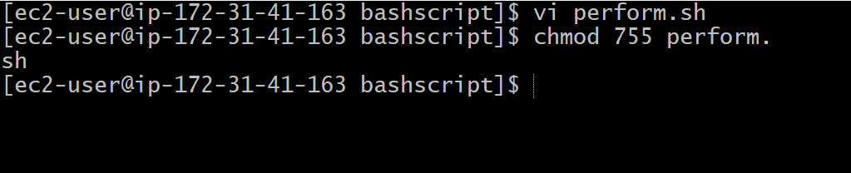

* Execute the file by keyword = ./

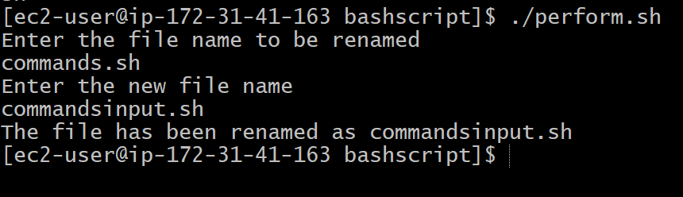

**Class Recording Video Tasks**

**1 Simple output to screen**

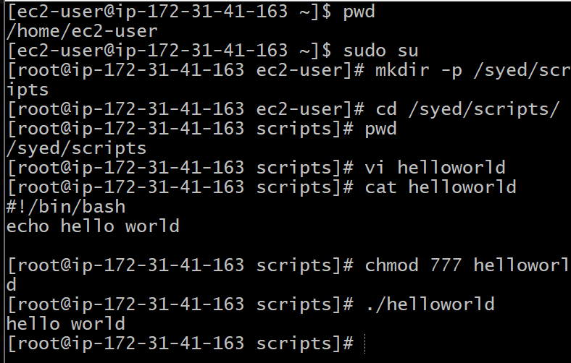

**Script:**  
#!/bin/bash  
# Simple output script  
echo "Hello World"

**2. Output permission**

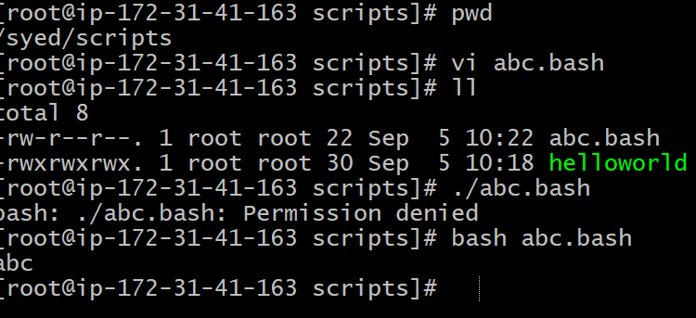

**3. Comands Scripts:**

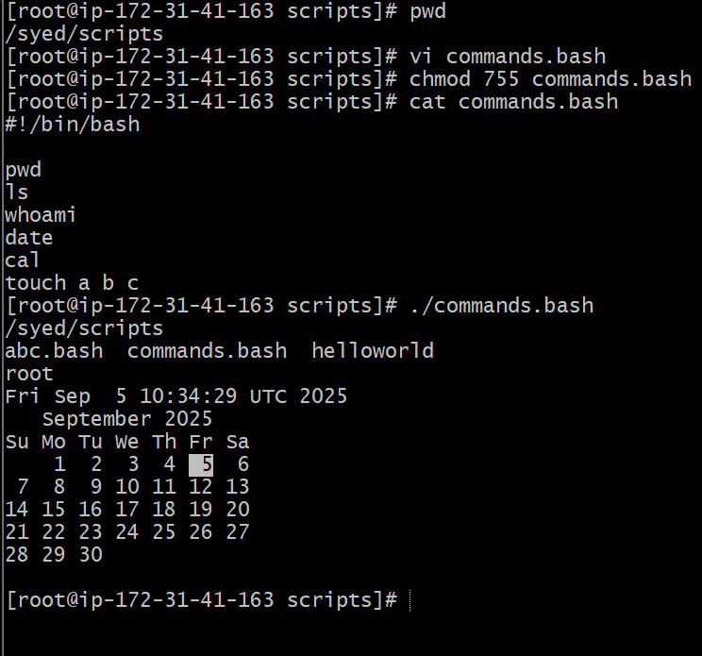

**Script:**

#!bin/bash

Pwd

Ls

Whoami

Cal

Touch a b c

**4. Define small tasks:**

**Script:**

whoami

echo

pwd

echo

hostname

echo

ls -ltr

echo

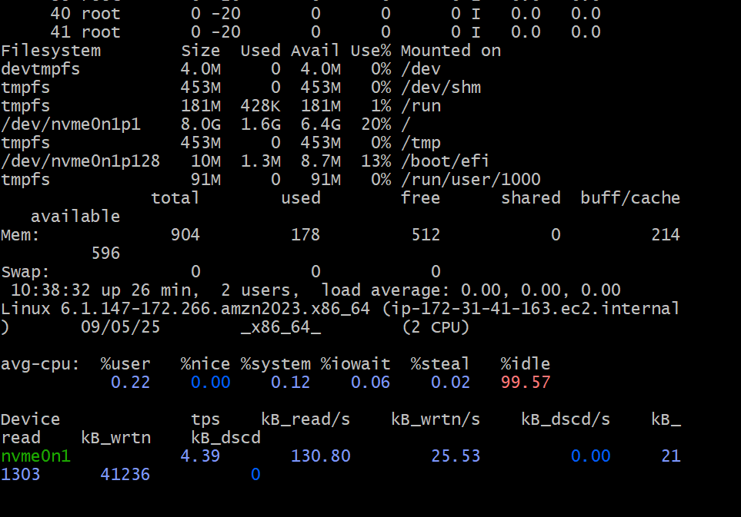

**5. Read Input:**

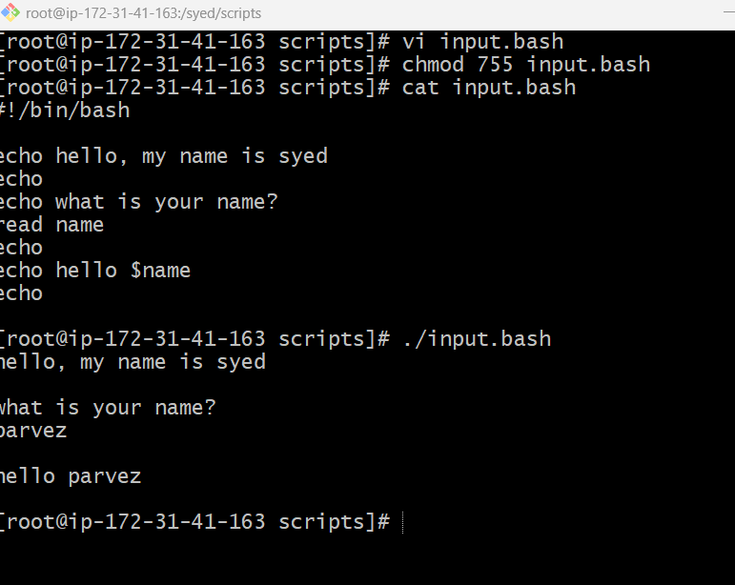

**Script:**

* Create a file and write the script which takes input from the user:
* Change the permission: chmod 755 input.sh
* “Enter your name” and it will display the output.

**7. Read input and perform a task:**

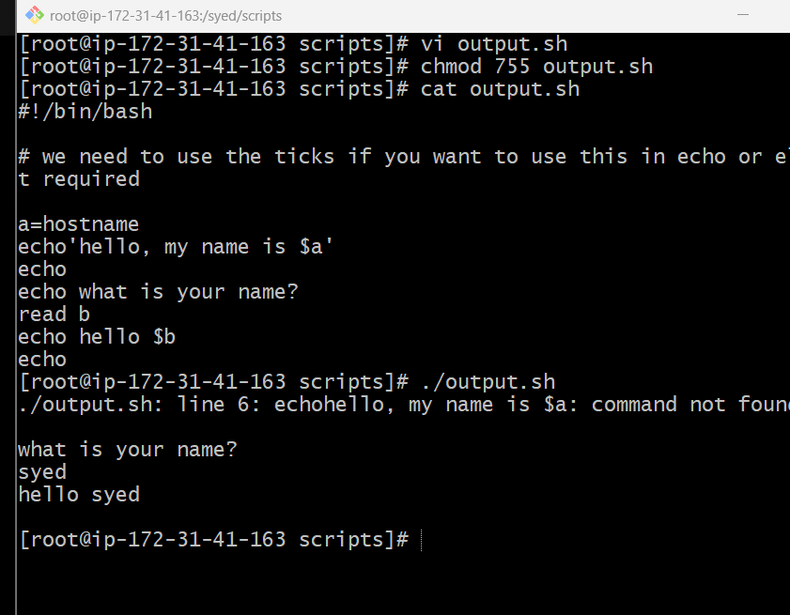

**Steps:**

* Create a file and write the script which takes input from the user:
* Change the permission: chmod 755 output.sh
* “Enter your name” and it will display the output.